|  |  |  |
| --- | --- | --- |
| *Final Report on*  ***“পল্লীহাট”*** | | |
| *Submitted to,*  SPL II Evaluation Committee 2020-2021  Bachelor of Science in Software Engineering  Institute of Information Technology  Noakhali Science and Technology University | | |
| ***Submitted By,*** | | |
| Sanzida Sultana  sanzida2514@student.nstu.edu.bd | Sultana Marjan  marjan2514@student.nstu.edu.bd | Fardin Ahosan Shawon  fardin2514@student.nstu.edu.bd |
| ***Supervised By*** | | |
| Md. Nuruzzaman Bhuiyan  [nuruzzaman.iit@nstu.edu.bd](mailto:nuruzzaman.iit@nstu.edu.bd) | | |
| Submission Date: 20-09-22 | | |

|  |
| --- |
| Final Report on  ***“পল্লীহাট”***    By, |

|  |  |  |
| --- | --- | --- |
| --------------------------  Sanzida Sultana  BKH1825010F  Year-3 Term-1  sanzida2514@student.nstu.edu.b | -------------------------------  Sultana Marjan  BKH1925010F  Year-3 Term-1  marjan2514@student.nstu.edu.bd | ----------------------------  Fardin Ahosan Shawon  ASH1825019M  Year-3 Term-1  fardin2514@student.nstu.edu.bd |
| Approved by | | |
| -----------------------------------  Md. Nuruzzaman Bhuiyan  Assistant Professor  Institute of Information Technology  Noakhali Science and Technology University  [nuruzzaman.iit@nstu.edu.bd](mailto:nuruzzaman.iit@nstu.edu.bd) | | |

|  |
| --- |
|  |

Contents

Software Project Description 5

Introduction 5

Target Users 5

Requirements 6

Functional Requirements 6

Functional Requirements 6

Models, Tools and resources 7

Agile Model 7

Tools 8

Programming Language 8

Text Editor 8

Local Server 8

Web Server 8

Resources 8

Project Members 9

Supervisor 9

Team Members 9

Proposed Timeline 9

Actual Timeline 10

User Guide 11

Home Page 11

New Products 13

Recommendation 14

Customer’s role 15

Customer Registration 15

Email Verification 15

Verify Customer 16

Customer Login 16

Change Password 17

Cart Functionalities 17

Customer Order 18

Customer Feedback 18

Admin side: 19

Dashboard 19

Add category: 19

Update category: 20

Order Details 20

Manage Entrepreneur: 21

Add Entrepreneur: 22

Generate Invoice: 22

Entrepreneur’s role 23

Add Product 23

Update Product 24

Entrepreneur’s Order 25

Entrepreneur can see customer’s feedback 25

Source Code Documentation 26

Software Project Metrics 26

Code Level 26

Function name & Description 27

SRS and Development Mapping 29

Challenges and Future Work 32

Challenges 32

Future Work 32

# Software Project Description

## Introduction

Our software project is **“পল্লীহাট”**. It’s a web-based application. The stakeholders of our project are the system owner, entrepreneurs, customers, employees. Our system **“পল্লীহাট”** is a way to present our culture through the artistic skills of rural and tribal people. We have create an e-commerce site that will change the lives of rural and tribal people across the country by selling their homemade cottages. The cottage industry plays an important role in preserving our culture and heritage. Our system creates a market where entrepreneurs can sell their products directly to customers at their preferred price, and consumers can buy their desired handicrafts from corresponding entrepreneurs. In our system, we add an advanced searching option which will helps the customer to find products easily and quickly. Customer can provide valuable reviews based on their purchasing products experience. Our project will be one of the few opportunities for financially disadvantaged women with remarkable abilities to work. As a result, we're working on this project with the specific purpose of conserving our culture while also bringing rural society to the forefront, in the hopes of opening up new opportunities in our country. Entrepreneurs can use our sites to sell their homemade cottages. System owner has the ability to control entrepreneurs and customers accounts, product categories, product information, as well as entire system. An entrepreneur can add their product to its compatible category and also add product description and product price. After adding the product, customers can view it on our website and can confirm orders to buy products from appropriate entrepreneur.

## Target Users

There are four types of target users of our system:

**System owner:** The system owner has the ability to control the entire system. The system owner is responsible for adding entrepreneurs, managing product categories, coordinating order processing, and monitoring and maintaining the website's appropriate function.

**Entrepreneur:** Entrepreneurs are those who made their homemade crafts and will sell them on our website.

**Customer:** Our website allows customers to purchase things. Customers can place an order for a product by sending a purchase request and they will be benefitted from the use of this system.

**Employees:** Employees will be largely responsible for overseeing our systems and communicating between customers and entrepreneurs. They will be benefitted from the use of this site

## Requirements

A requirement is a singular documented physical or functional need that a particular design, product or process aims to ensure safety. It can be divided into functional requirements and non-functional requirements.

### Functional Requirements

Functional requirements are those requirements that are used to illustrate the internal working nature of the system, the system, and explanation of each subsystem. It consists of what task the system should perform, the processes involved, which data the system should hold and the interfaces with the user.

* User registration and login
* System owner can control members
* System owner can unregister members
* Manage Categories and products
* System owner can manage order
* Customer can provide rating and feedback
* Customer can manage their shopping cart
* Customer can update own profile
* Add homemade cottage for sale
* Customer can search for desired products
* System owner can manage customer’s feedback

### Functional Requirements

* Storing image data
* Speed and latency requirements
* Precision and accuracy requirements
* Capacity requirements
* Dependability requirements
* Availability and Reliability requirements
* Safety requirements
* Maintainability and supportability requirements
* Security requirements
* Access requirements
* Integrity requirements
* Privacy Requirements
* Usability and Human-interaction requirements
* Look and feel requirements

## Models, Tools and resources

**Models**

In our system the requirements are clear and fixed and there are no ambiguous requirements, so we used agile model.

### Agile Model

We follow agile model in our project. Agile SDLC model is a combination of iterative and incremental process models with focus on process adaptability and customer satisfaction by rapid delivery of working software product. Agile methods break the product into small incremental builds. These builds are provided in iterations. It works by first admitting that old “waterfall” method of software development leaves a lot to be desired. It abandons the risk of spending months or years on a process that ultimately fails because of some small mistake in an early phase. It relies instead on trusting employees and teams to work directly with customers to understand the goals and provide solutions in a fast and incremental way.

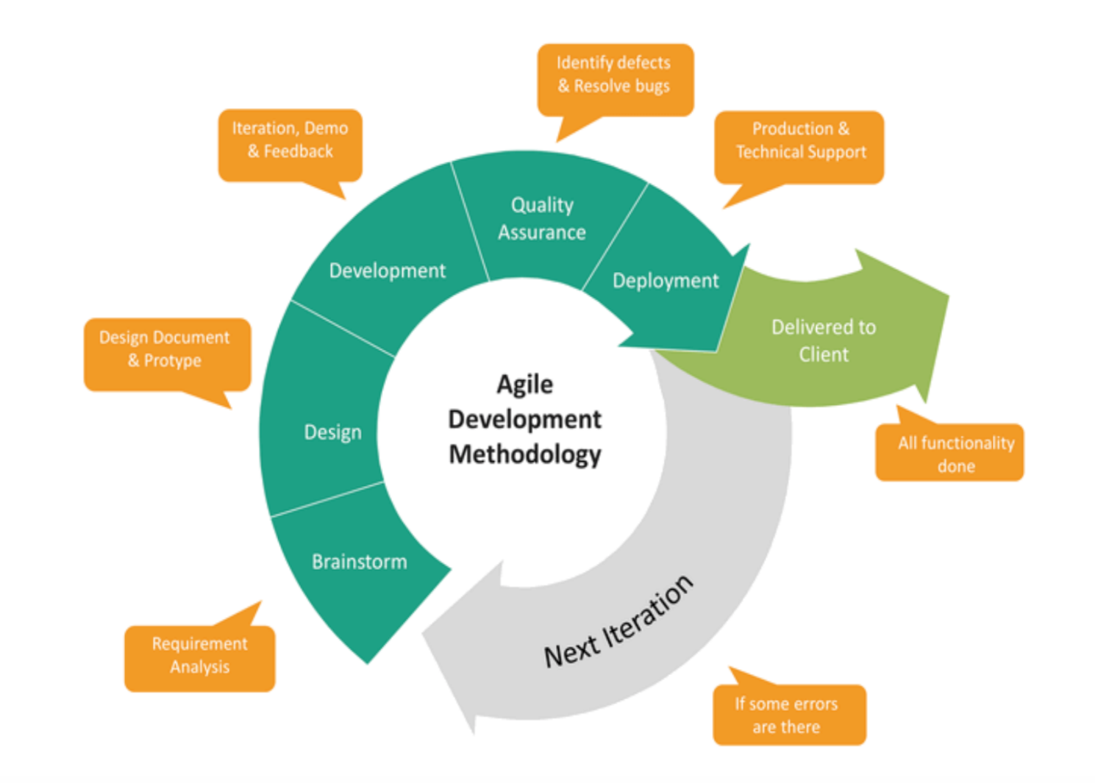

Figure: Agile Model

## Tools

### Programming Language

A programming language is a set of commands, instructions, and other syntax use to create a software program. Languages that programmers use to write code are called "high-level languages." We have used PHP, Javascript as programming language to develop our application. Mainly, PHP are used to develop this project.

### Text Editor

Visual Studio Code

### Local Server

Xampp Control Panel

**Database Server**

The MySQL server provides a database management system with querying and connectivity capabilities, as well as the ability to have excellent data structure and integration with many different platforms. It can handle large databases reliably and quickly in high-demanding production environments. It is a stable, reliable and powerful solution with advanced features like the following:

* + - Data Security
    - On-Demand Scalability
    - High Performance
    - Round-the-clock Uptime
    - Comprehensive Transactional Support
    - Complete Workflow Control
    - The Flexibility of Open Source
    - Fault tolerance

### Web Server

A Web server is a program that uses HTTP (Hypertext Transfer Protocol) to serve the files that form Web pages to users, in response to their requests, which are forwarded by their computers' HTTP clients. Dedicated computers and appliances may be referred to as Web servers as well. We have used the Apache HTTP server to implement this project.

### Resources

* https:// [getbootstrap.com/docs/5.0/getting-started/introduction/](https://l.facebook.com/l.php?u=http%3A%2F%2Fgetbootstrap.com%2Fdocs%2F5.0%2Fgetting-started%2Fintroduction%2F%3Ffbclid%3DIwAR1eSBMC1Ax6MB40c9o8aiz5tWO55waNRZqZAn9qc3O-1HWGFHIYBDV5t98&h=AT28G6MFsh-TdjmyJDiK4kbkbABh1XqiNSr04TQoN-9gy46T450V3mpU8seeP-tbS49C6DDvrMr4IvgirTOqyRRqtyPx3yWxkAXpexO_cO8i-_2b-k900l0CfD7T-el_iuNAbw)
* https:// [developer.mozilla.org/en-US/docs/Web/JavaScript](https://l.facebook.com/l.php?u=http%3A%2F%2Fdeveloper.mozilla.org%2Fen-US%2Fdocs%2FWeb%2FJavaScript%3Ffbclid%3DIwAR2hCwA4kxgLFX2d0C1TEQ_8ewduhWxmCQFQ2rBI4W6E4n_j6gBLGBsfes0&h=AT28G6MFsh-TdjmyJDiK4kbkbABh1XqiNSr04TQoN-9gy46T450V3mpU8seeP-tbS49C6DDvrMr4IvgirTOqyRRqtyPx3yWxkAXpexO_cO8i-_2b-k900l0CfD7T-el_iuNAbw)
* https:// [www.php.net/docs.php](https://l.facebook.com/l.php?u=http%3A%2F%2Fwww.php.net%2Fdocs.php%3Ffbclid%3DIwAR0lJfe93NUXMMeOcNnMgUD7edl5hCz7PkaqeVqHGsPkhiJTNn2Ou0dXodY&h=AT28G6MFsh-TdjmyJDiK4kbkbABh1XqiNSr04TQoN-9gy46T450V3mpU8seeP-tbS49C6DDvrMr4IvgirTOqyRRqtyPx3yWxkAXpexO_cO8i-_2b-k900l0CfD7T-el_iuNAbw)
* https:// [developer.mozilla.org/en-US/docs/Web/HTML](https://l.facebook.com/l.php?u=http%3A%2F%2Fdeveloper.mozilla.org%2Fen-US%2Fdocs%2FWeb%2FHTML%3Ffbclid%3DIwAR0zDRU9aQaY5tpZAQWkKOpcaIZiGck5NoxaGGj4Sbdjqg58XYjuz3P2Wfo&h=AT28G6MFsh-TdjmyJDiK4kbkbABh1XqiNSr04TQoN-9gy46T450V3mpU8seeP-tbS49C6DDvrMr4IvgirTOqyRRqtyPx3yWxkAXpexO_cO8i-_2b-k900l0CfD7T-el_iuNAbw)
* https:// [developer.mozilla.org/en-US/docs/Web/CSS](https://l.facebook.com/l.php?u=http%3A%2F%2Fdeveloper.mozilla.org%2Fen-US%2Fdocs%2FWeb%2FCSS%3Ffbclid%3DIwAR3LwqdoXXwc2l_C42s5-F53PD0zmZG79PyPxxxvDDVulhD49Fg5GjHq4_A&h=AT28G6MFsh-TdjmyJDiK4kbkbABh1XqiNSr04TQoN-9gy46T450V3mpU8seeP-tbS49C6DDvrMr4IvgirTOqyRRqtyPx3yWxkAXpexO_cO8i-_2b-k900l0CfD7T-el_iuNAbw)
* https:// [developer.mozilla.org/en-US/docs/Web/Guide/AJAX](http://developer.mozilla.org/en-US/docs/Web/Guide/AJAX?fbclid=IwAR2sRNmX6uW8RVO6Uxt7SBl-WSdQsr3_puRWw-z1tXD_NbGzChd-ZS185wU)

## Project Members

**Project Team: Shonirvor**

### Supervisor

Md. Nuruzzaman Bhuiyan

Assistant Professor

Institute of Information Technology

### Team Members

Sultana Marjan(BKH1925010F)

Sanzida Sultana(BKH1825010F)

Fardin Ahosan Shawon(ASH1825019M)

## Proposed Timeline

Proposed timeline is the timeline which are made by guess in a time bound and actual timeline means the work history which is make after completed work.

**Figure : Proposed Timeline**

## Actual Timeline

**Figure : Actual Timeline**

## User Guide

In this section, students will describe how a user will operate the software. It may include figures of user interfaces.

### Home Page

* A user or customer can visit out site at any time if he is not our registered member. Anyone who wants to buy products online can visit our site at any time.



**Figure: Home Page**



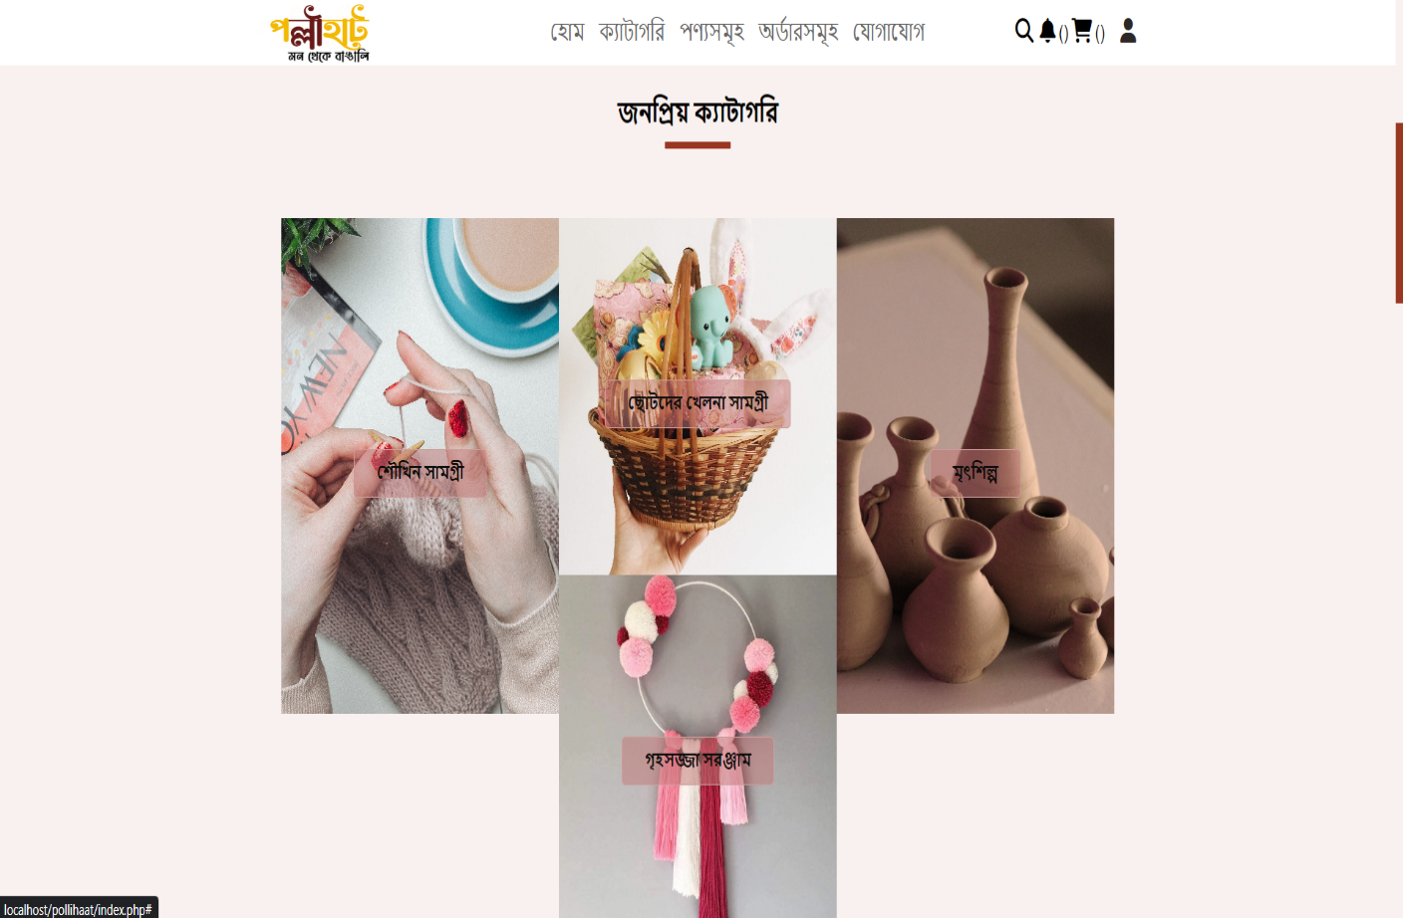

**Figure: Home Page**

### New Products

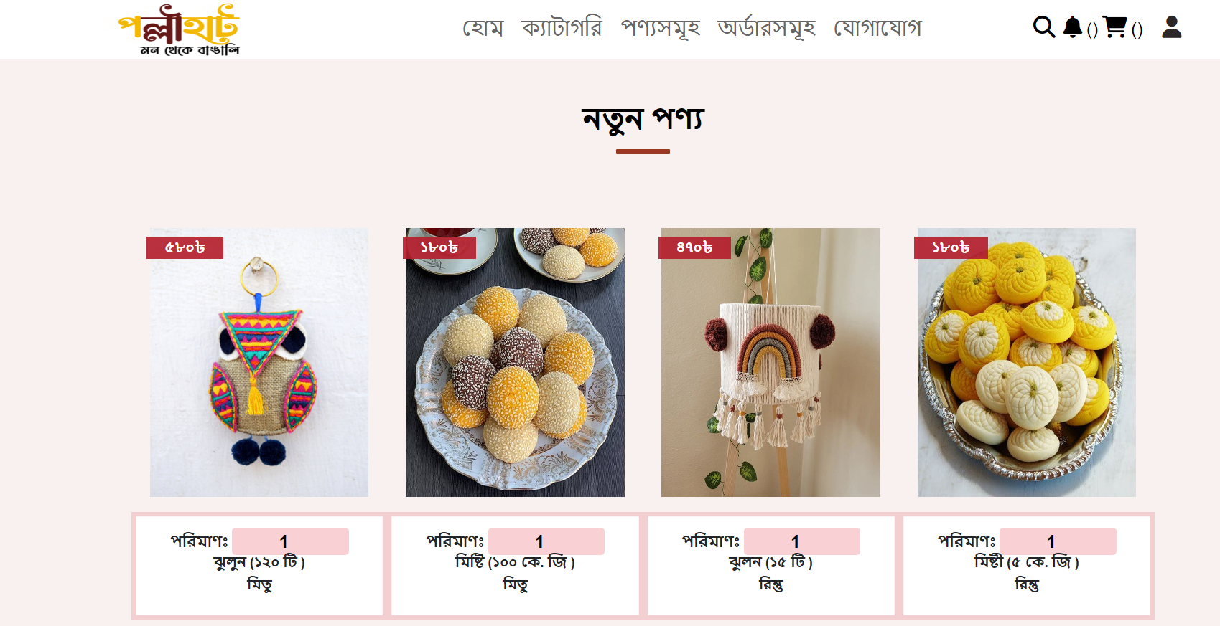

**Figure: New Products**

### Recommendation

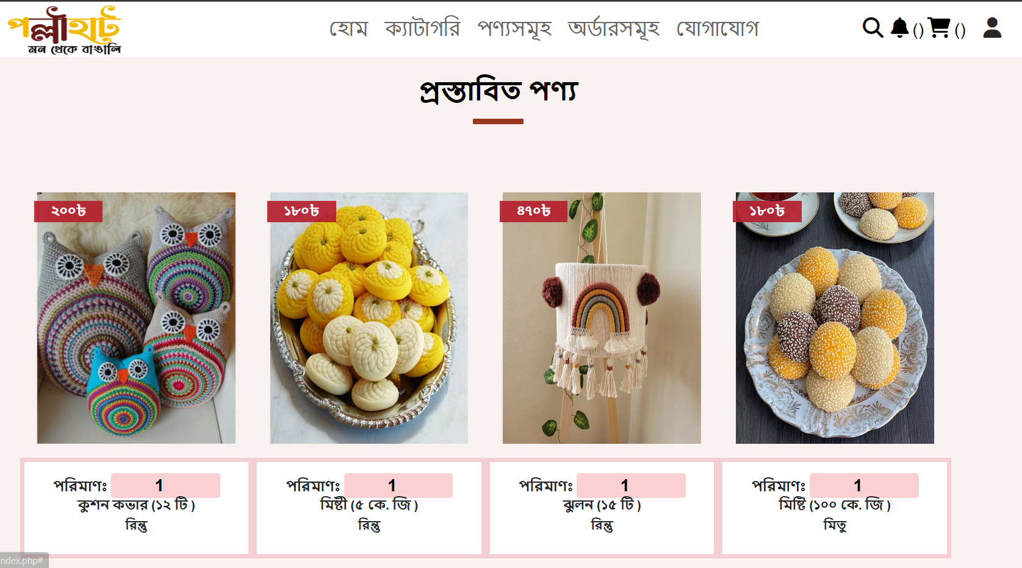

**Figure: Recommendation**

## Customer’s role

### Customer Registration

* If a person wants to buy products from our site, he must register on our site by following the procedure shown below. To register, a customer must provide name, email, mobile number and then must click on the “রেজিস্টার” button.

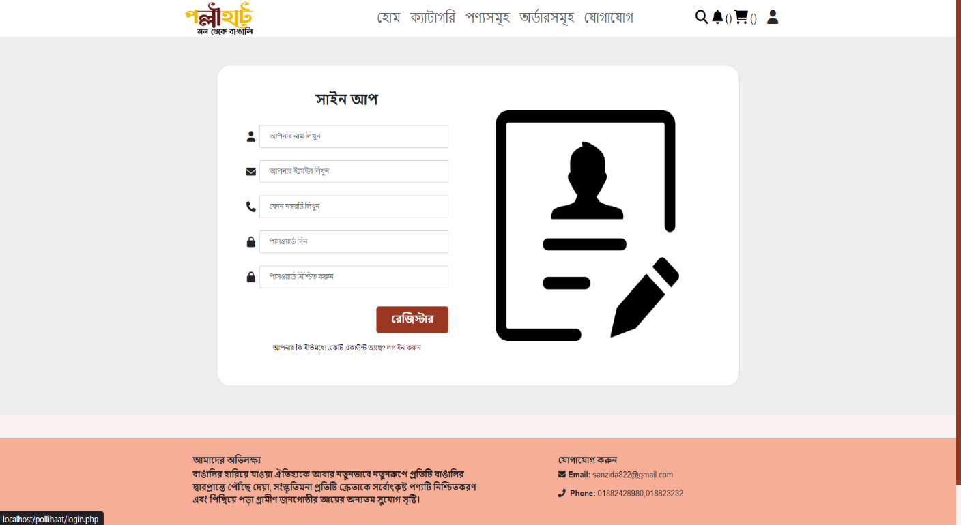

**Figure: Customer Registration**

### Email Verification

* The system will send a verification code to the user on his provided mail.

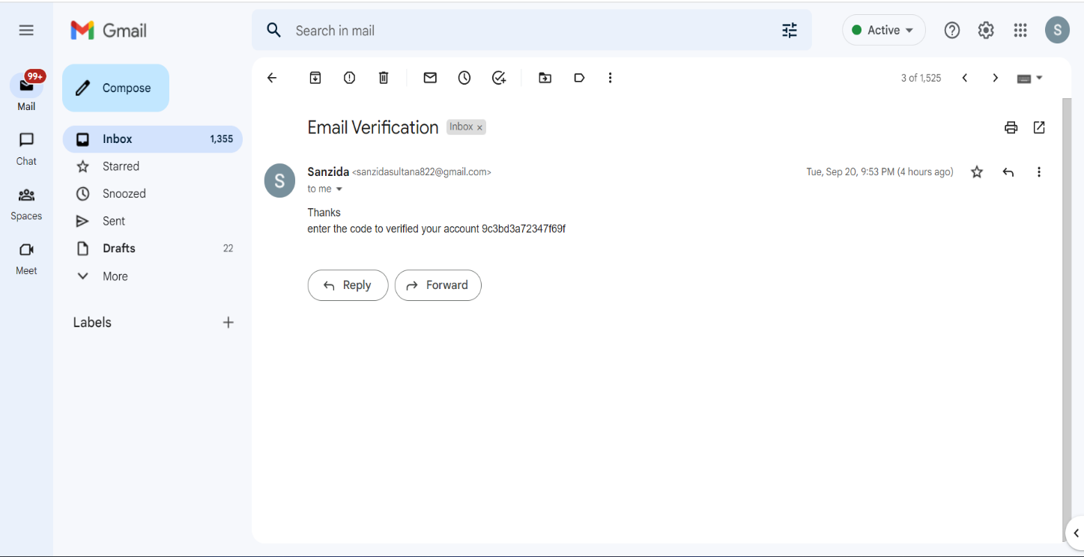

**Figure : Email verification**

### Verify Customer

* Then the user will verify his email with the verification code.

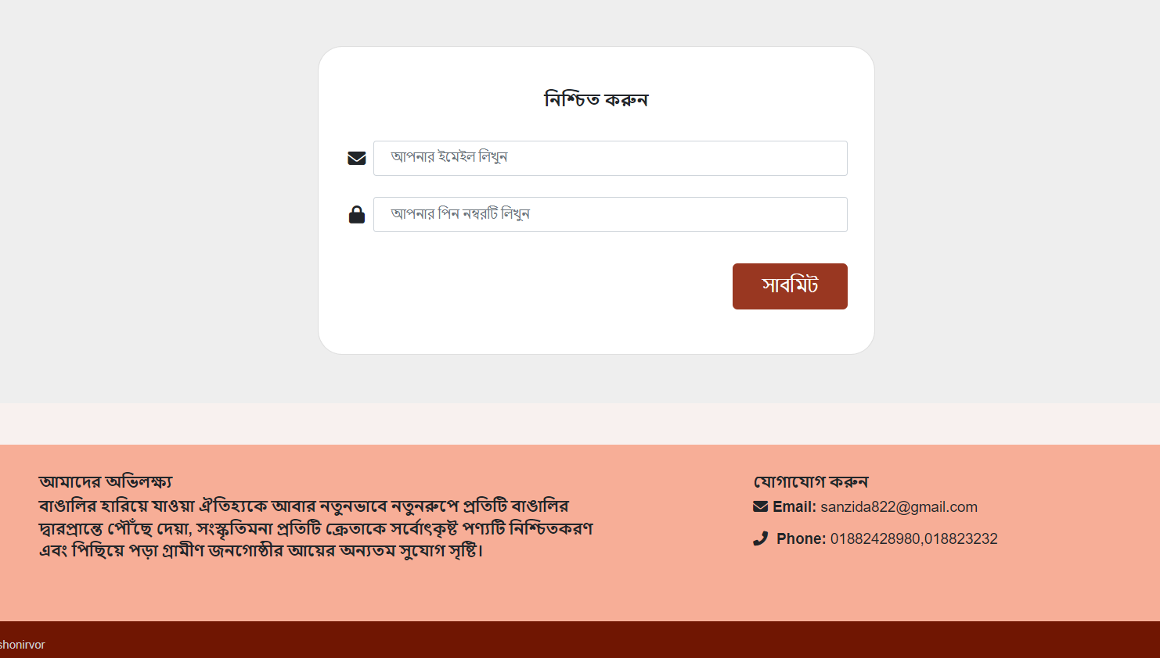

**Figure: Verify Password**

### Customer Login

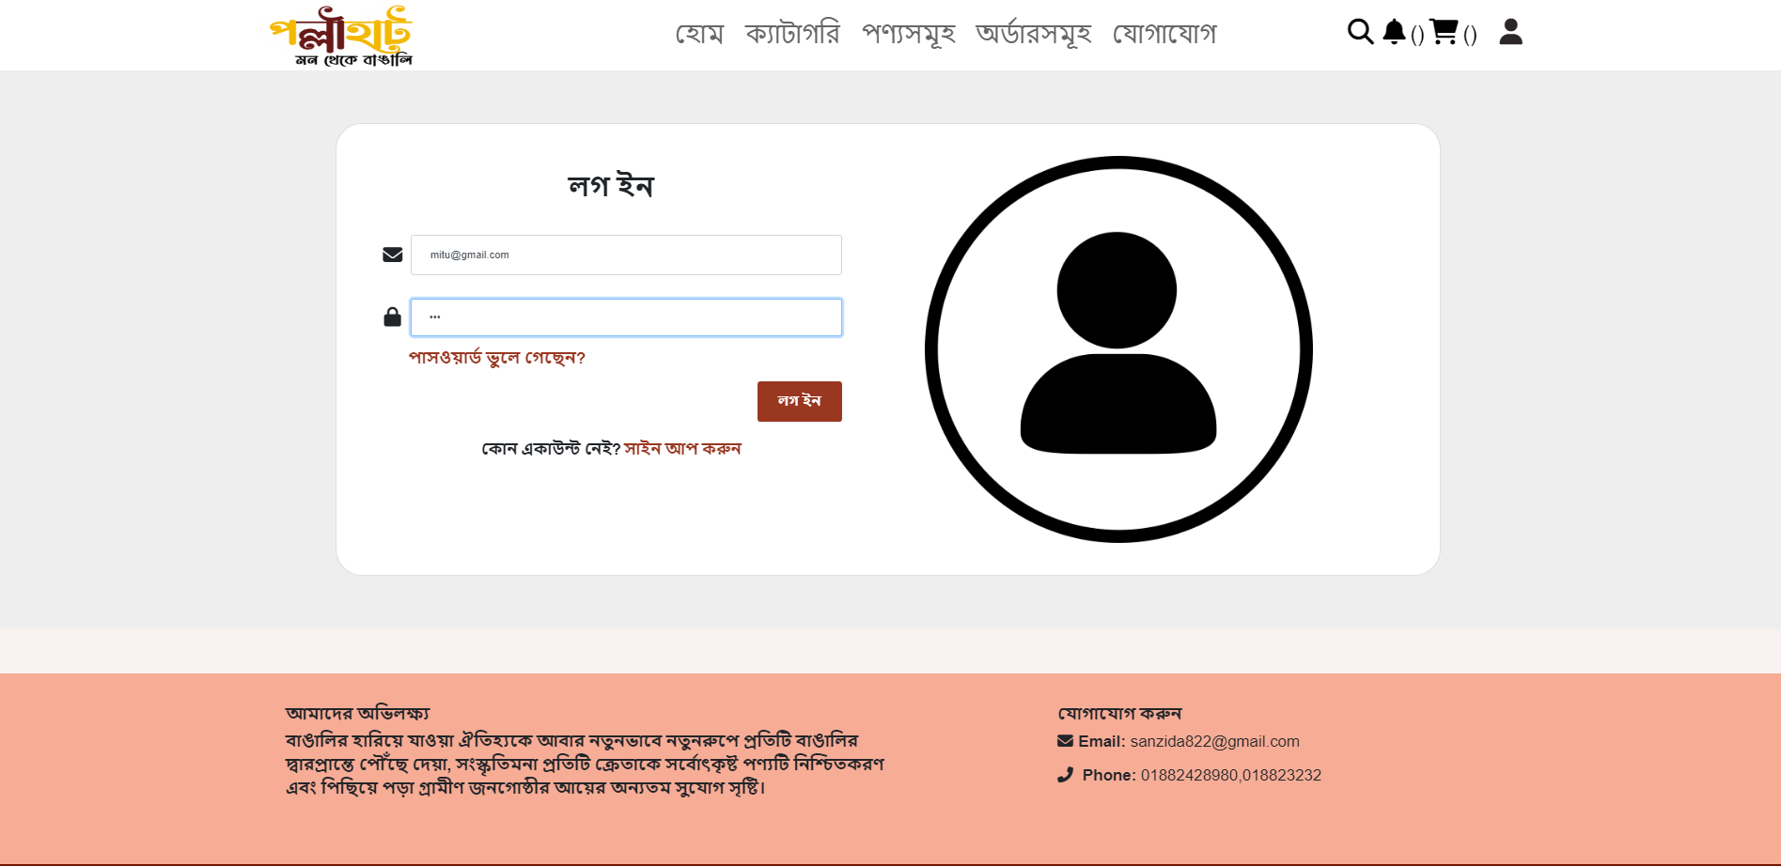

**Figure: Customer Login**

### Change Password

* If the user forgets his password, he can reset the password through system verification.

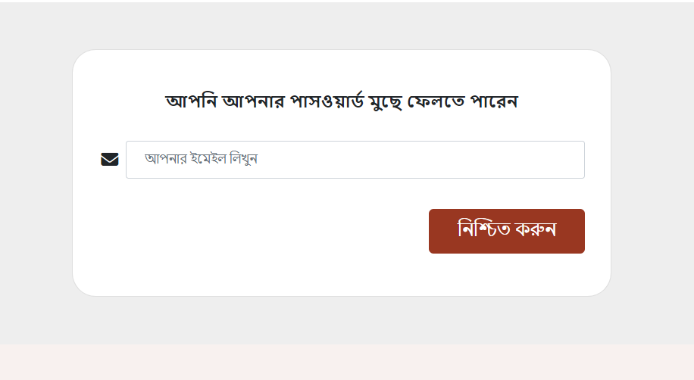

**Figure: Change Password**

### Cart Functionalities

* If the user wants to buy any product, he can select the quantity of the product and add it to the cart. User can also update and delete products in the cart as per his wish.

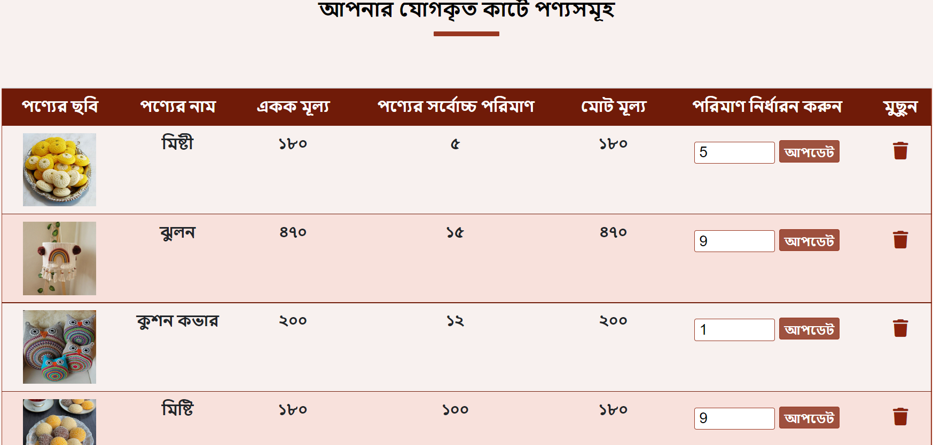

**Figure: Cart functionalities**

### Customer Order

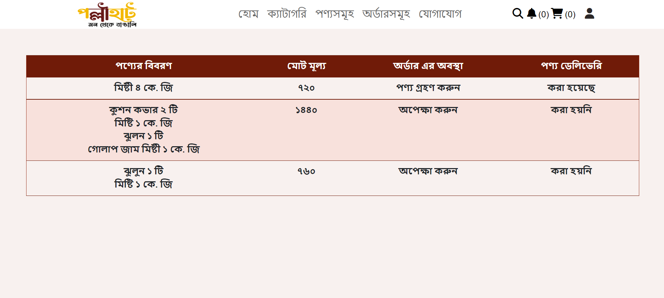

**Figure : Customer Order**

### Customer Feedback

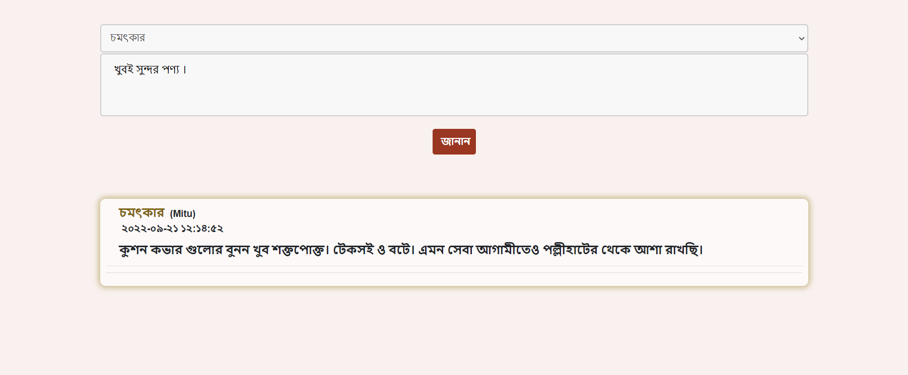

**Figure : Customer Feedback**

## Admin side:

### Dashboard

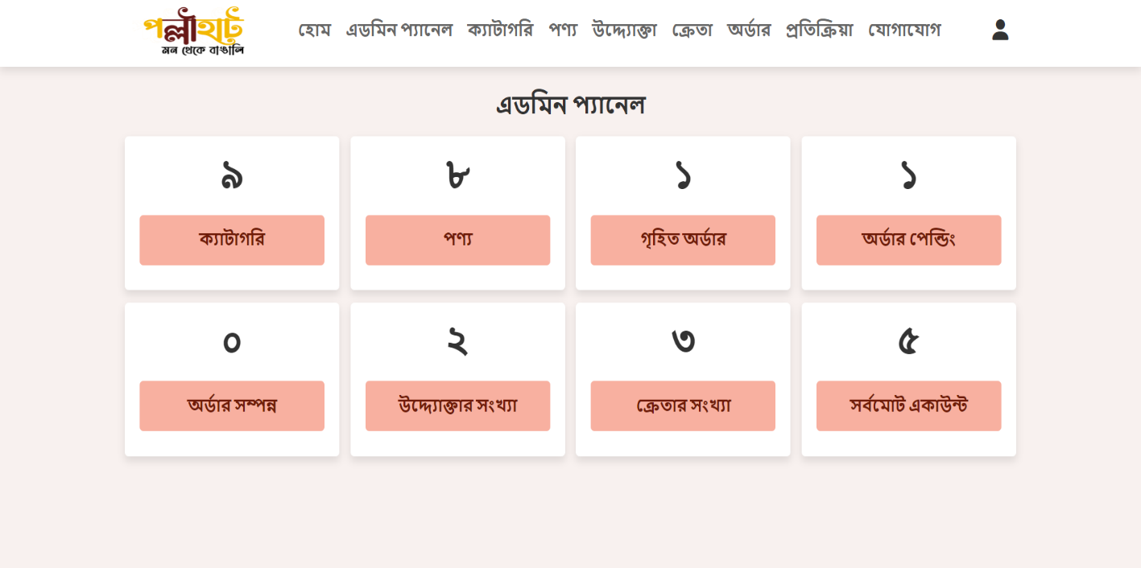

**Figure : Dashboard**

### Add category:

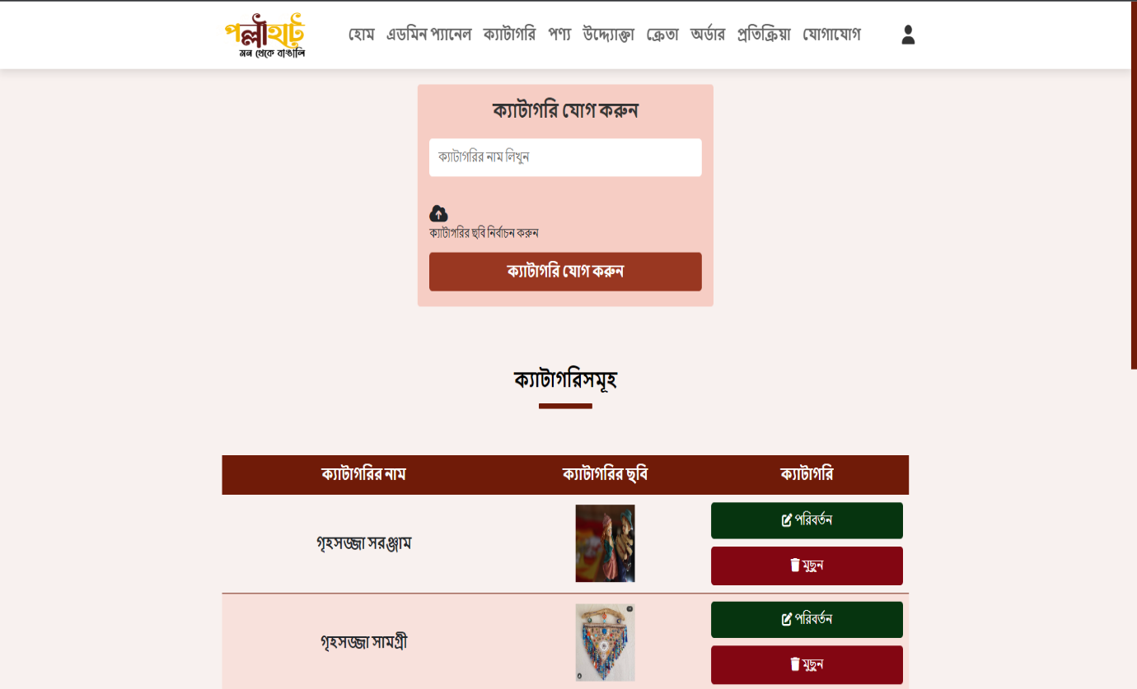

**Figure : Add Category**

### Update category:

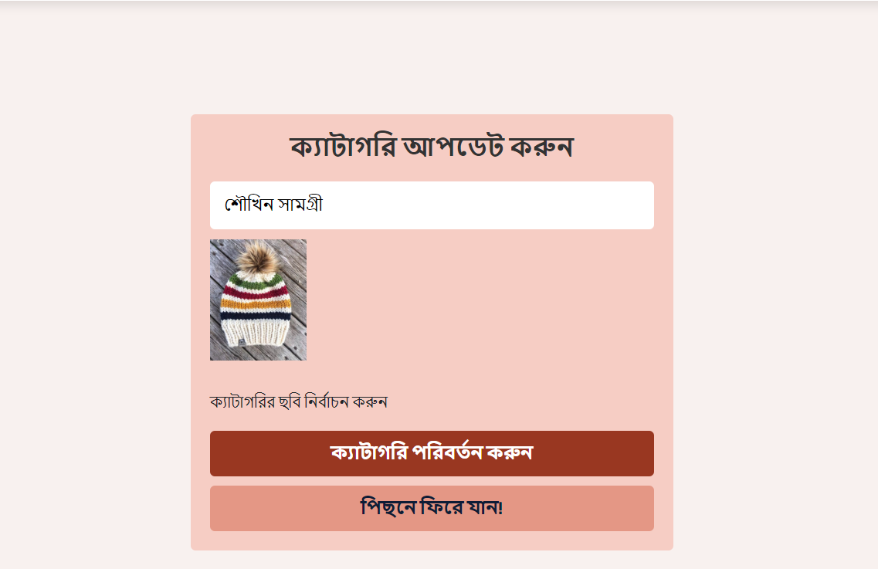

**Figure : Update Category**

### Order Details

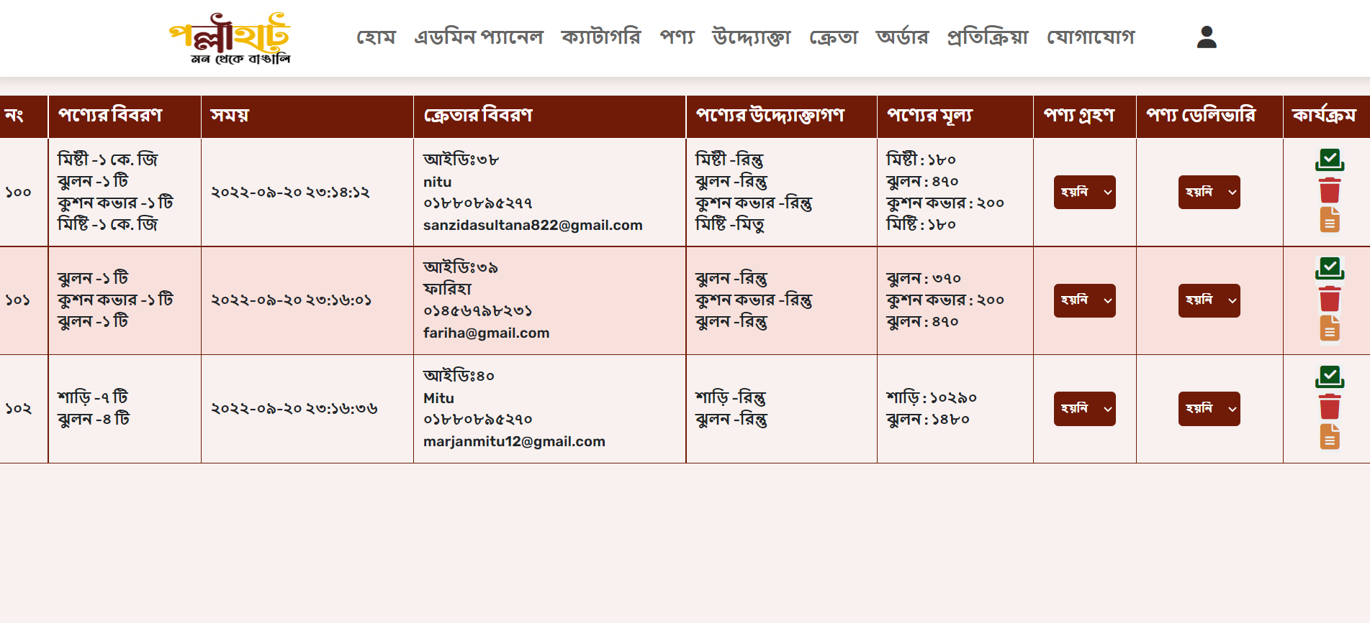

**Figure: Order Details**

* After receiving the product from the entrepreneur, the admin will update the order and the system will send a mail to the customer that the product is ready for pick up.

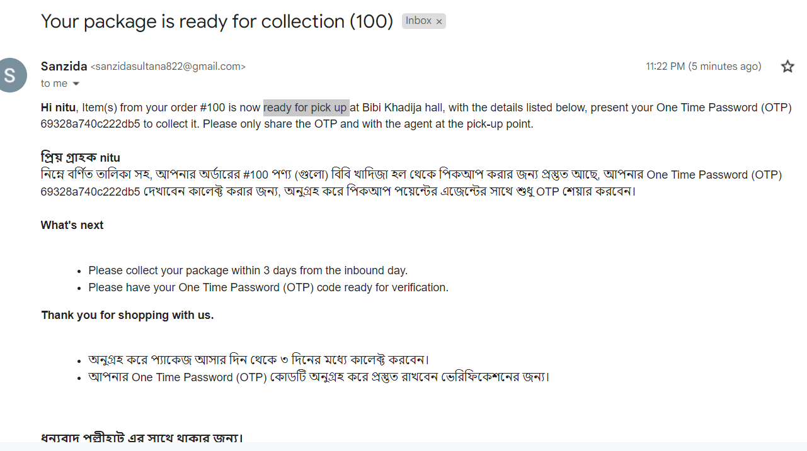

**Figure: Email for receiving products**

### Manage Entrepreneur:

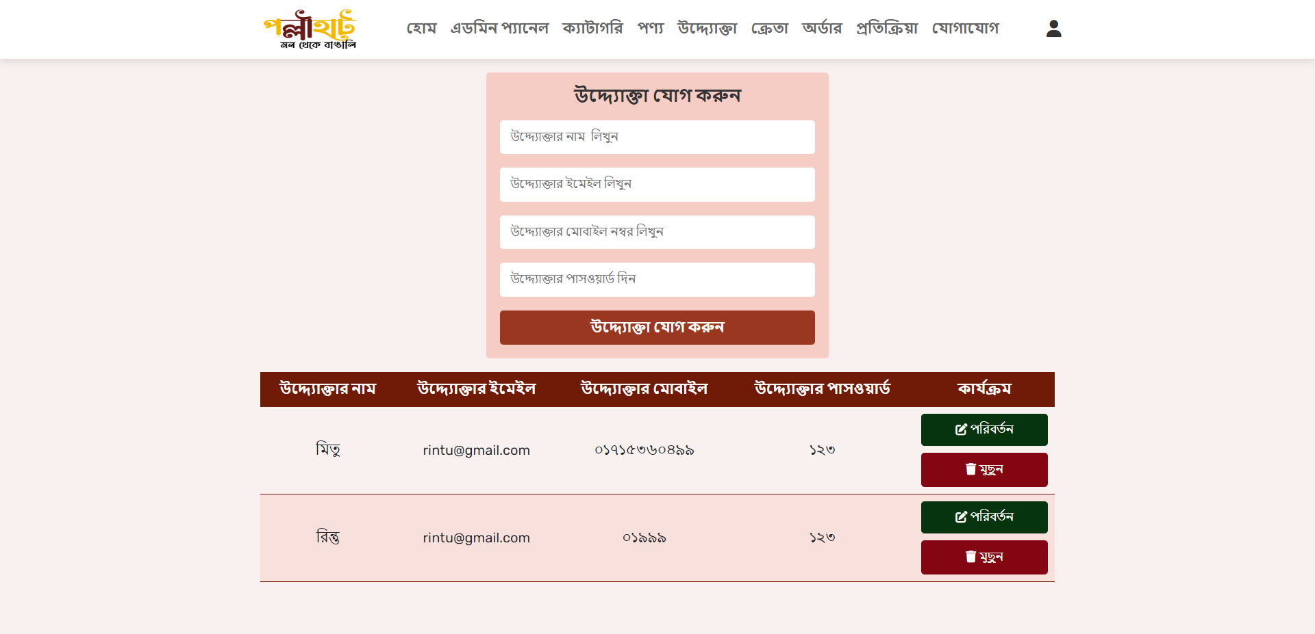

**Figure : Manage Entrepreneur**

### Add Entrepreneur:

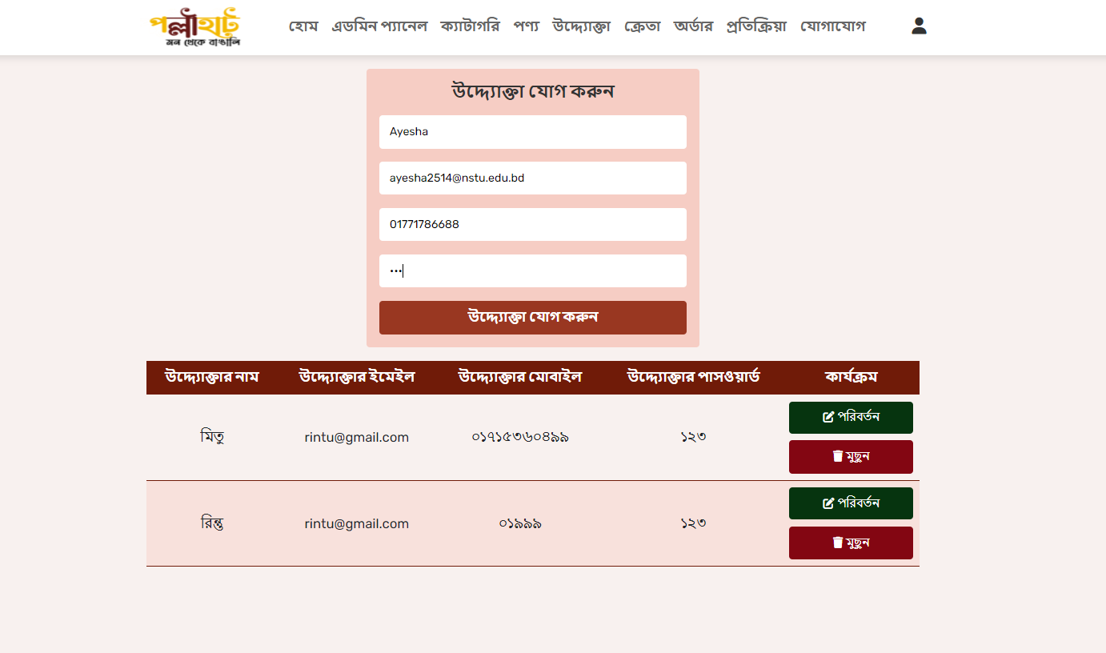

**Figure : Add Entrepreneur**

### Generate Invoice:

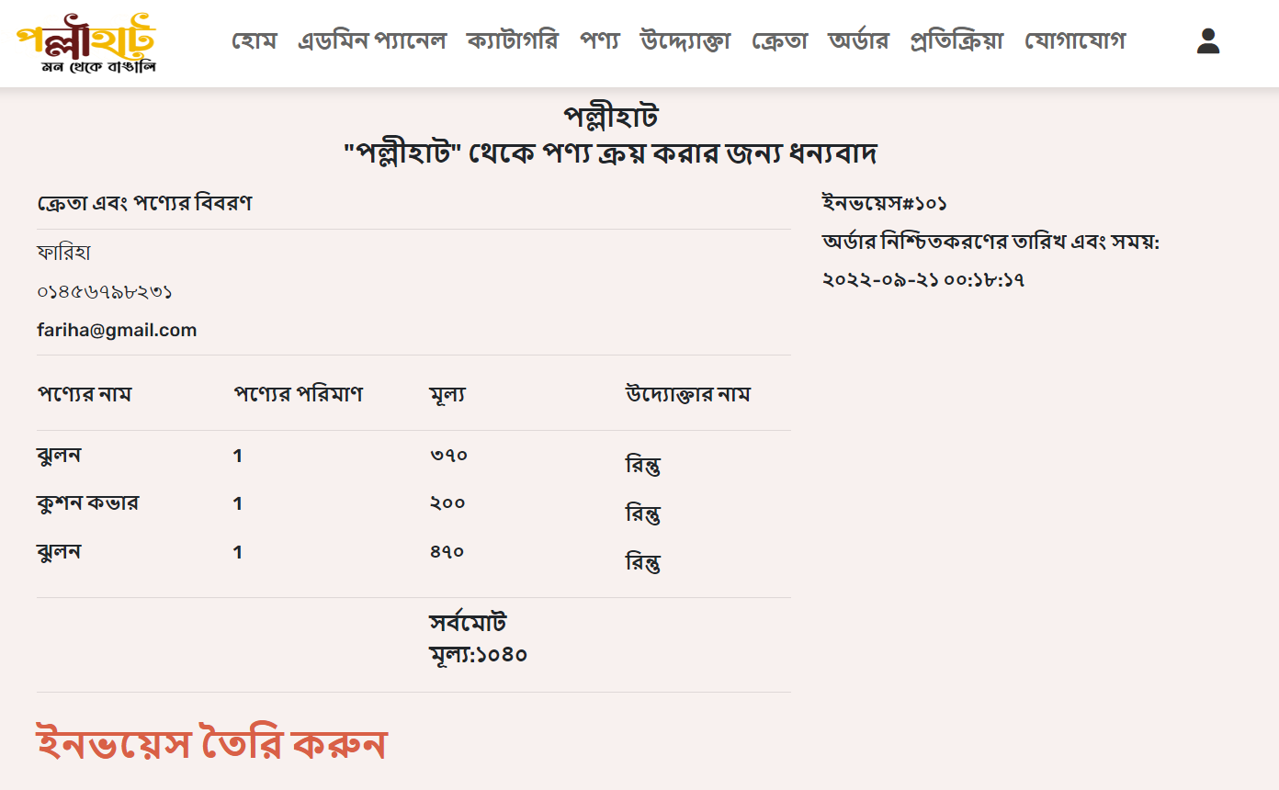

**Figure : Generate Invoice**

## Entrepreneur’s role

### Add Product

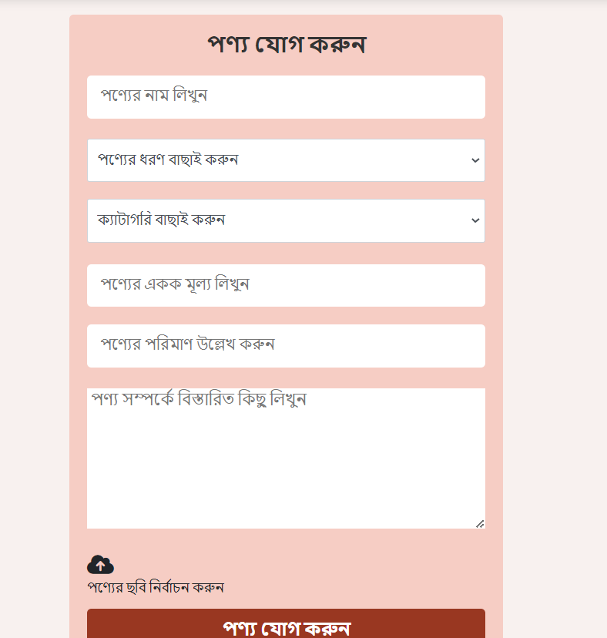

**Figure : Add Product**

### Update Product

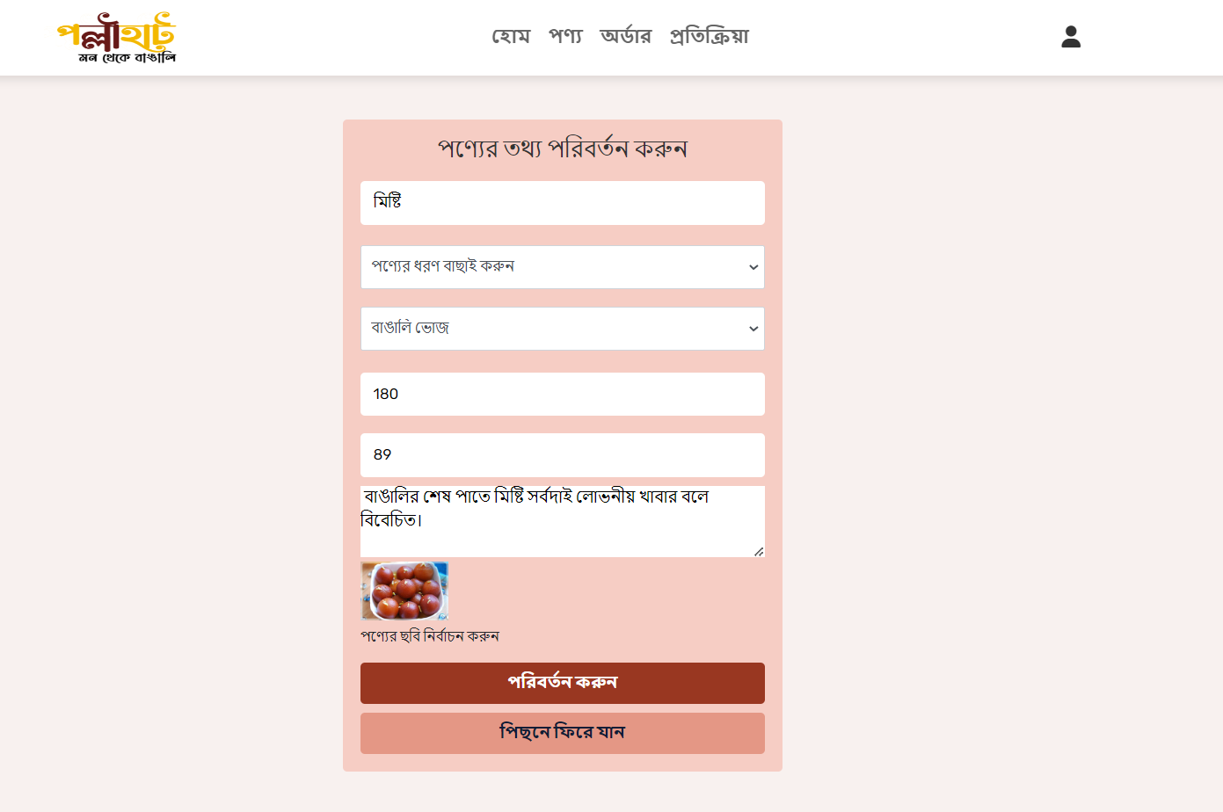

**Figure : Update Product**

### Entrepreneur’s Order

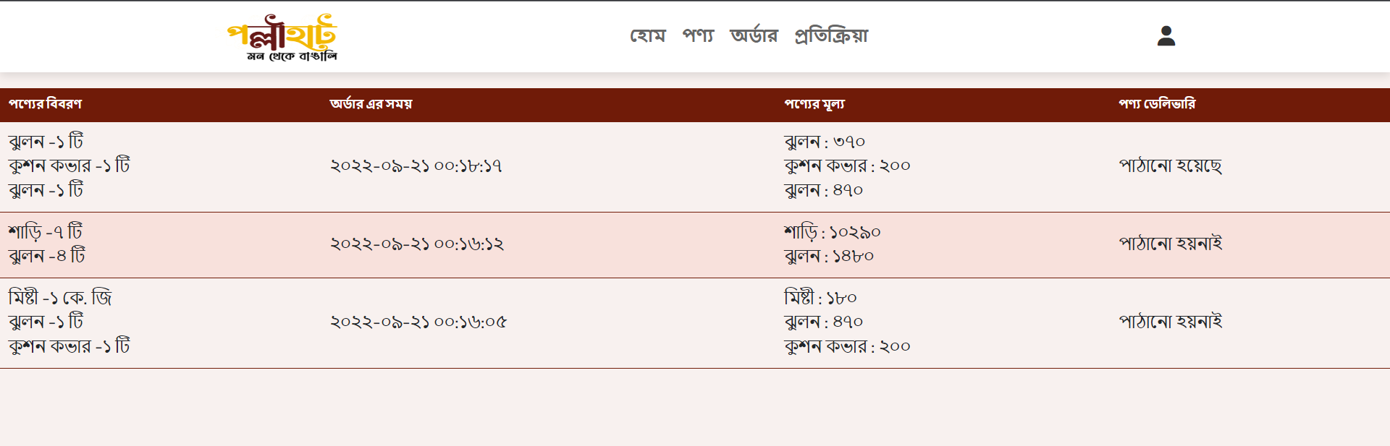

**Figure: Entrepreneur’s Order**

### Entrepreneur can see customer’s feedback

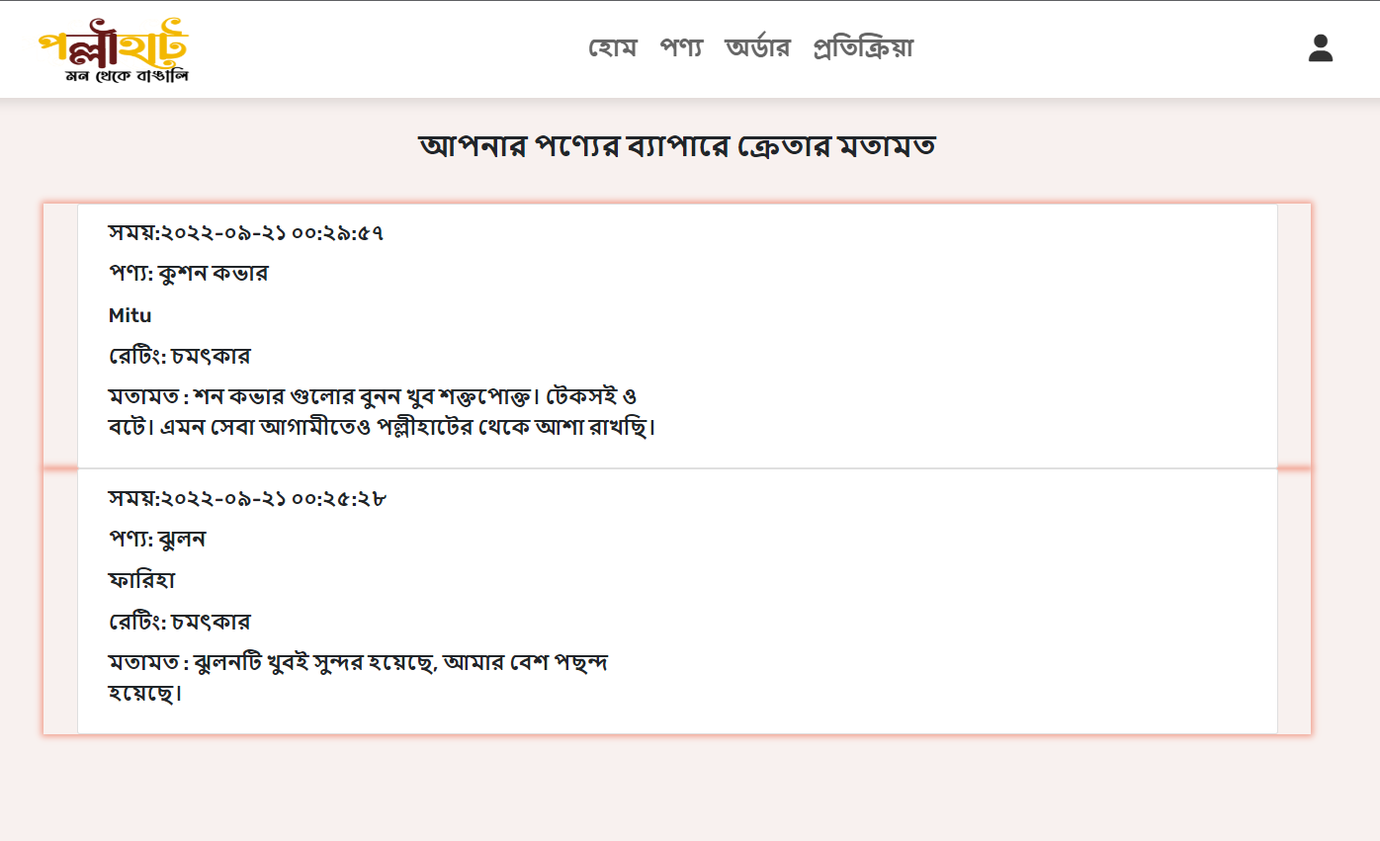

**Figure: Feedback**

## Source Code Documentation

It will contain the code of the structure of the project, metrices i.e. lines of code and API documentation. The description of a function, its parameters and its returns are written in API documentation.

### Software Project Metrics

### Code Level

**LOC-** Line of code in the whole project. The Total number of code lines in whole project.

**NCLOC-** Non-comment line of code. The total number of code lines in whole project.

**CLOC-**Comment line of code- The line of code which are not working to calculate output.

**Average LOC in a class-** The average number of line of code in each class.

|  |  |
| --- | --- |
| LOC | 28493 |
| NCLOC | 23012 |
| CLOC | 5481 |
| Average LOC | 321 |
| Density of Comments | 7% |

## Function name & Description

|  |  |
| --- | --- |
| **Function name** | **Description** |
| getInstance():object | This method always returns a single object of the Database class. |
| check_login($email:String,$password:  String):boolean | Takes the login info from user input and after checking and validating the info from the database logs in a user to the system or declares login failed on incorrect information. |
| userExist($email):boolean | Checks if the customer's given email exists in the database |
| sendMail($email:String,$v_code:String) | It sends a verification code to the customer to identify if the customer is a valid user |
| insertCustomer($customerData:array()) | Takes the signup info as array and successfully creates and sends a verification code to the customer’s email. |
| insertCart($data:array()) | It inserts the products and quantity of the products into the cart that the customer wants to buy |
| deleteCart($cartId:int) | It deletes cart items that customers want to delete |
| updateCart($cartId:int,$quantity:int) | It updates the product quantity in any customer's cart. |
| deleteAllFromCart($customerId:int) | This deletes all information from the customer cart. |
| checkDuplicate($productId:int,  $customerId:int)  :boolean | It checks whether the customer has added duplicate product IDs to the cart. |
| getAllValues($customerId:int):array() | Takes the customers ID as an input and returns all cart information. |
| getAllReview():array() | It returns all reviews of a particular product that the customer has provided. |
| deleteReview($id) | It deletes any specific product review. |
| insertReview($reviewData:array())  : array | It takes customer review data as an input array and inserts it into the database. |
| insertCustomerOrder($customerId:int,  $date:date()) | It takes the customer ID and date as input and inserts the order into the database. |
| getCustomerOrder($customerId:int):  array () | It takes the customer id as an input and returns all orders of that customer. |
| **Function Name** | **Description** |
| getReceiveOrnot($orderId:int): array() | It takes the order id as input and returns whether or not the product has been received from the entrepreneur. |
| categoryDuplicate($name:String) | It takes the category name as an input and checks if the database has the same category. |
| insertCat($name:String,$image) | It inserts any product category name and its image into the database. |
| EntrepreneurDelete($name:String) | It takes the entrepreneur's name as an input and deletes all information of the entrepreneur if the name is found in the database. |
| showOrder($orderId:int,$name:String) | It takes order id and entrepreneur name as an input and returns all available orders given to the entrepreneur. |
| searchProduct($name:String) | It takes product name as an input and searches it from the database. |
| insertProduct($productData:array) | It takes product data as an array and inserts the products information into the database. |
| getProductCat($id:int) | It takes product id as an input and returns  the category information as an array. |
| quantityUpdate($id:int,$qty:int) | It updates the quantity of the given product ID. |
| getProductPrice($productsId:int,$quantity:int) | It takes the product id and quantity as an input and returns the calculated price of that product. |
| sendMail($customerDetails:array(),$oid:int,  $v_code:String) | It sends mail to the customer when the product is received from the entrepreneur. |

## SRS and Development Mapping

|  |  |  |
| --- | --- | --- |
| **SL No** | **Use Case** | **File/Class** |
| 01 | Registration | registration.php isVerified.inc.php  registration.class.php |
| 02 | Login | login.php  login.inc.php  user.class.php |
| 03 | Change password | forgetpassword.php  isVerified.inc.php  registration.class.php |
| 04 | Search product | search.php  products.class.php |
| 05 | Manage shopping Cart | cart.php  cart.inc.php  add_cart.class.php |
| 06 | Post rating and review | product.php  review.inc.php  review.class.php |
| 07 | Place order | cart.php  checkout.inc.php  customerOrder.class.php |
| **SL No** | **Use Case** | **File/Class** |
| 08 | Add category | category.php  addCategory.inc.php  categories.class.php |
| 09 | Manage category | manageCategory.php  manageCat.inc.php  manageCategory.class.php |
| 10 | Add product | product.php  addProduct.inc.php  products.class.php |
| 11 | Manage product | manageProduct.php  manageProd.inc.php  manageProduct.class.php |
| 12 | Add entrepreneur | entrepreneur.php  addEntrepreneur.inc.php  entrepreneur.class.php |
| 13 | Manage entrepreneur | manageEntrepreneur.php  manageEntrepreneur.inc.php  EntrepreneurDetailsCheck.class.php |
| 14 | Generate invoice | invoice.php  order.inc.php  invoice.class.php |
| 15 | Manage feedback | review.php  manageReview.inc.php  review.class.php |
| **SL No** | **Use Case** | **File/Class** |
| 16 | View customer details | customer.php  customer.class.php |
| 17 | View order details | orderDetails.php  entrepreneurOrderDetails.php  orderDetails.class.php  entrepreneurOrder.class.php |
| 18 | Receive product from entrepreneur | orderDetails.php  order.inc.php  order.class.php |

## Challenges and Future Work

## 

### Challenges

* **Lack of infrastructure:**

Lack of infrastructure and enough technical skills of the rural people to use the online-based marketplace effectively is a big challenge for us to market this system.

* **Quality Control:**

To acquire customers' trust, we must always pay attention to the product's quality, because the higher the product's quality, the higher the demand for the product. As our entrepreneurs are rural and tribal people, it is difficult for us to maintain product quality.

* **Create a user-friendly site:**

As we focused on rural, tribal people it was a big challenge for us to make this site user friendly.

* **Connectivity problem:**

As our system is online based and at the same time its entrepreneurs are mainly rural people so getting internet access is a bit difficult for them.

### Future Work

Currently, our project is working on a small scale, but we have a lot of thoughts about it in future. We want to introduce it and deliver the product to every person in the whole world. Along with cash on delivery we will arrange online payment system. Also we will convert it in Android Application.